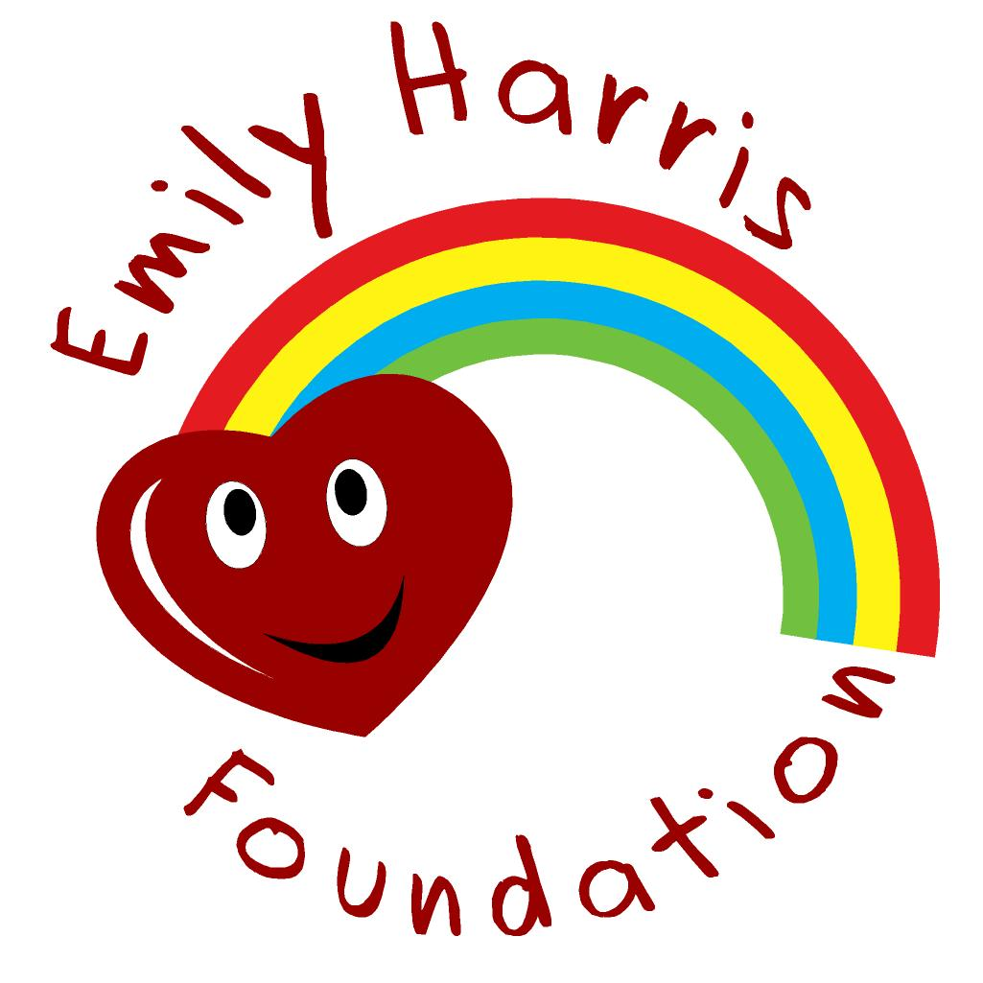

Gift Aid Declaration

Name of Charity – Emily Harris Foundation
Details of donor
Title ……Forename(s) …………………………………… Surname …………………
Home address …………………………………………………………………………………
……………………………………………………………………………………
………………………………………………… Post Code ……………………
I want the charity to treat
*the enclosed donation of £ ……………… as a Gift Aid donation
*the donation(s) of £ ………………………which I made on ……/……/…… as (a) Gift Aid donation (s)
*all donations that I make from the date of this declaration until I notify you otherwise as Gift Aid donations
*all donations I have made for this tax year and the six years prior to the year of this declaration, (but no earlier than 6/4/2000) and all donations I make from the date of this declaration until I notify you otherwise, as Gift Aid donations.
*delete as appropriate

You must pay an amount of Income Tax and/or Capital Gains Tax at least equal to the tax that the charity reclaims on your donations in the appropriate tax year (currently 25p for each £1 you give).

Date: ………/………/………

Notes:
- You can cancel this Declaration at any time by notifying the charity.
- If in the future your circumstances change and you no longer pay tax on your income and capital gains equal to the tax that the charity reclaims, you can cancel your declaration.
- If you pay tax at the higher rate you can claim further tax relief in your Self Assessment tax return.
- If you are unsure whether your donations qualify for Gift Aid tax relief, ask the charity.. Or, refer to donations by individuals.
- Please notify the charity if you change your name or address.

