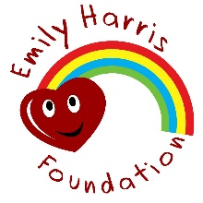
EMILY HARRIS FOUNDATION WORLD CUP PREDICTOR
£2
Name:______________________________ Contact No/email: .
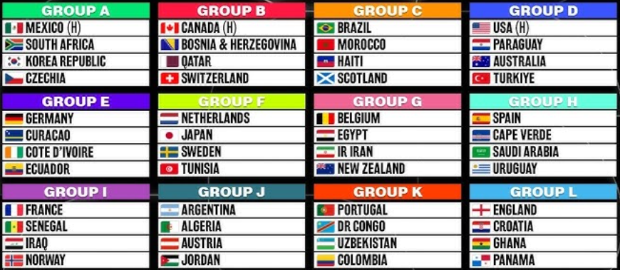
Top 2 in each group - 2 pts if you guess the right team in the right position. 1 point if the team finishes in the top 2 but not in the place predicted.
 | Group A | Group B | Group C | Group D
1st
2nd
 | Group E | Group F | Group G | Group H
1st
2nd
 | Group I | Group J | Group K | Group L
1st
2nd

8 Quarter-finalists – 1 point each (any order)
[Please note that the 8 highest scoring 3rd placed teams from the group stages will also go through to the next stage, so these teams can also feature in the quarter/semi-finals if they get through the rounds of 32 and 16!]
Team 1 | Team 2 | Team 3 | Team 4
Team 5 | Team 6 | Team 7 | Team 8

4 Semi-finalists – 1 point each (any order)
Team 1 | Team 2 | Team 3 | Team 4

2 Finalists – 1 point each
Team 1 | Team 2

Winner – Name the country you think will win the World Cup 2026 – 2 points

Number of Yellow Cards in the Final – 2 points

Top Goalscorer – Name the country from which the top goalscorer will come from – 2 points

Tie-Breaker – How many goals will be scored in total in the group games?

Entries will only be valid once payment of £2 has been received. This can be paid by cash, bank transfer (08-92-99; 67240748) or via our PayPal Giving page - https://www.paypal.com/uk/fundraiser/charity/4512830


Completed entry forms need to be returned no later than 6pm on Thursday 11th June 2026. Entries can be submitted via email to admin@emilyharrisfoundation.org or as a hard copy.

Thank you for taking part in our Men’s FIFA World Cup 2026 competition. To keep updated with the winners and losers, follow us on Social Media or sign up to our newsletter by sending an email to admin@emilyharrisfoundation.org







www.emilyharrisfoundation.org
Registered Charity No. 1196802

